**PeopleTools Assignment 2**

**NOTE: Where you see NAIT100 in the images below change the 100 to your PS NAIT user id.**

Project: ***NAIT###_COURSE***

*MENU > BAIST > NAIT### > Course*

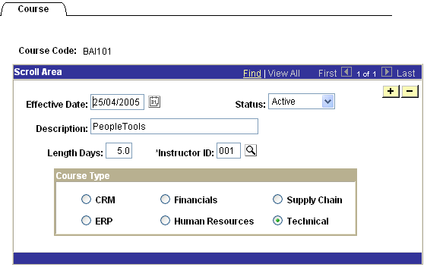

Fields:

NAIT###_COURSE_TYP

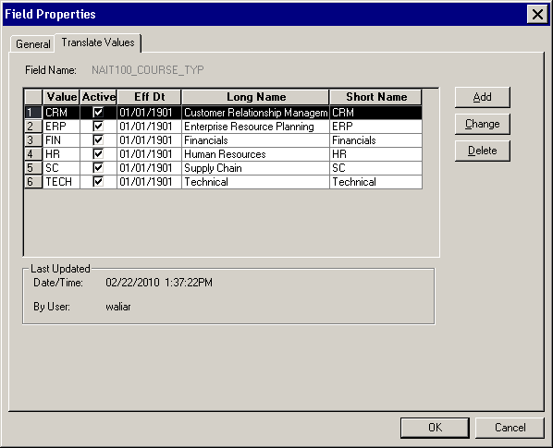

NAIT###_LENGTH_DAY

**Record:** NAIT###_COURSE

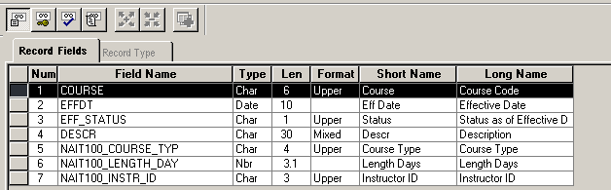

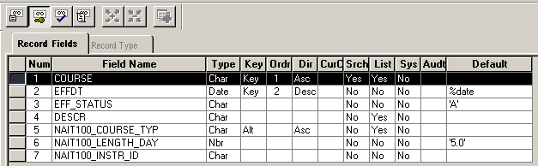

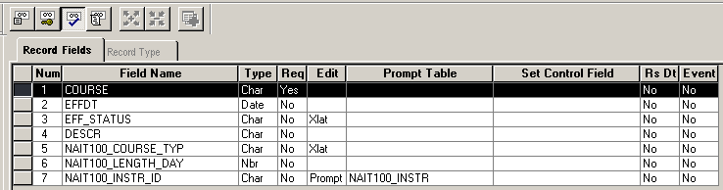

Required:

1. Complete the necessary steps (from the Eight Steps of Application Development (8-SAD) to add a record (through PeopleSoft Tools).
2. Add 5 rows of data in PeopleSoft Course page (Note: the data should be meaningful and test the validity of the record). You can assume all courses are active.